Lab 11
CLOUD COMPUTING

NAME:AREEJ FATIMA
REG-NO:2023-BSE-010

TASK A
taskA_codespace_create_and_list.png
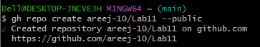
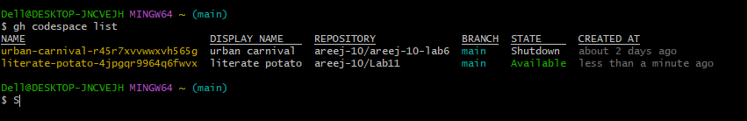taskA_codespace_ssh_connected.png
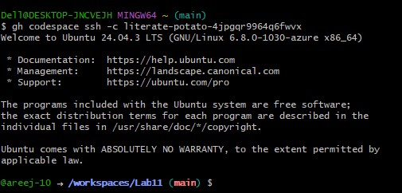
TASK 1: Provider & Basic Variable (Variable Precedence)
task1_touch_main_tf.png
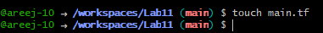
task1_main_tf_provider.png
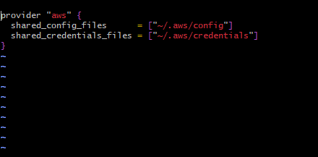
task1_terraform_init.png
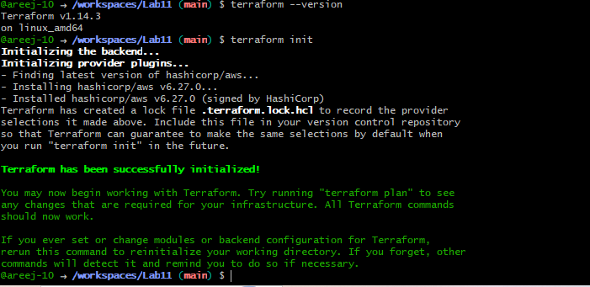
task1_variable_and_output_added.png
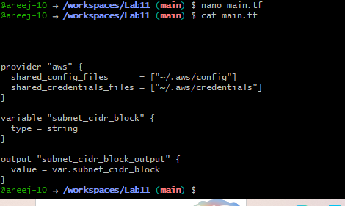
task1_apply_prompt_for_var.png
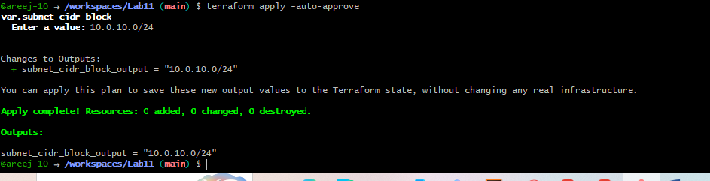
task1_apply_with_default.png
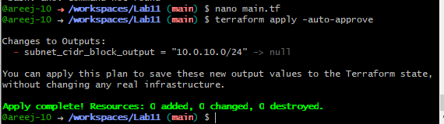
task1_env_var_set_and_apply.png
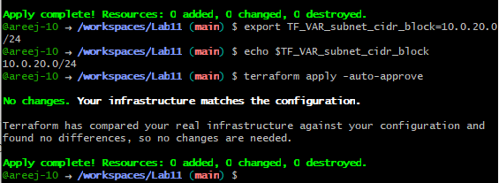
task1_terraform_tfvars_and_apply.png
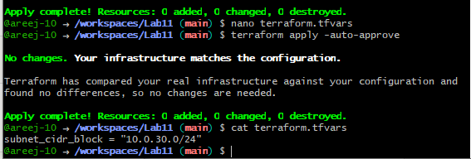
task1_var_override_with_dash_var.png
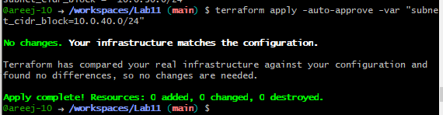
task1_printenv_tf_var_and_unset.png
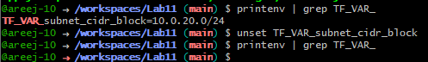
Task 2 — Variable validation & sensitive / ephemeral variables
task2_subnet_variable_with_validation.png
task2_subnet_validation_error.png
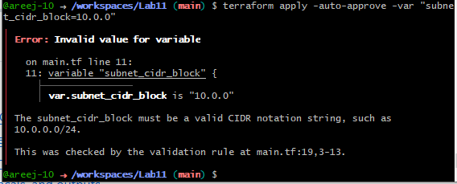
task2_api_token_variable_added.png
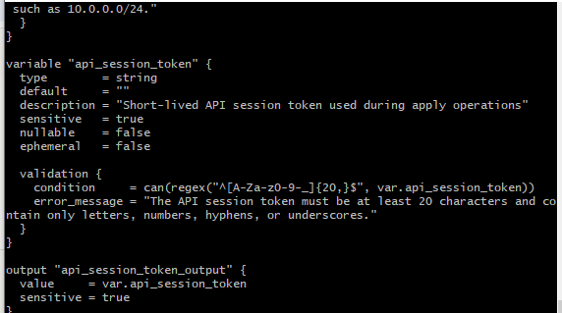
task2_api_token_apply_sensitive.png
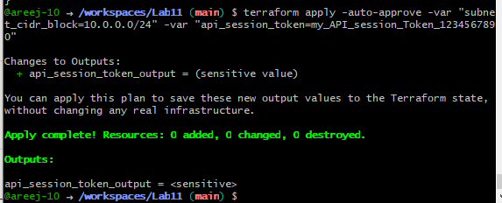
task2_check_terraform_state_api_token.png
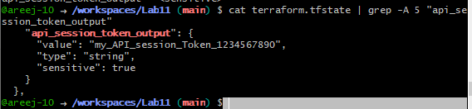
task2_api_token_default_apply.png

task2_api_token_ephemeral_error.png
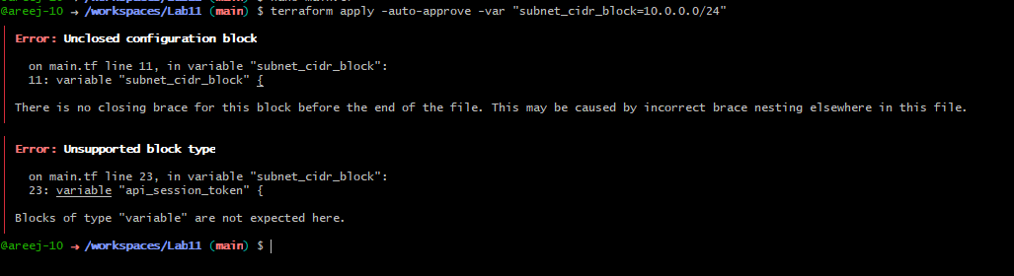

Task 3 — Project-level variables, locals, and outputs
task3_variables_added.png
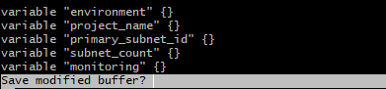
task3_terraform_tfvars_populated.png
subnet-06cf8046b6d80c766
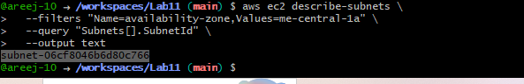
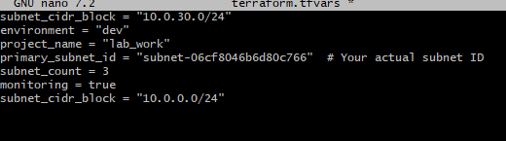
task3_locals_tf_created.png
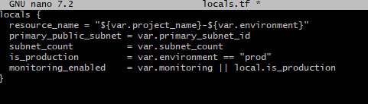
task3_outputs_apply.png
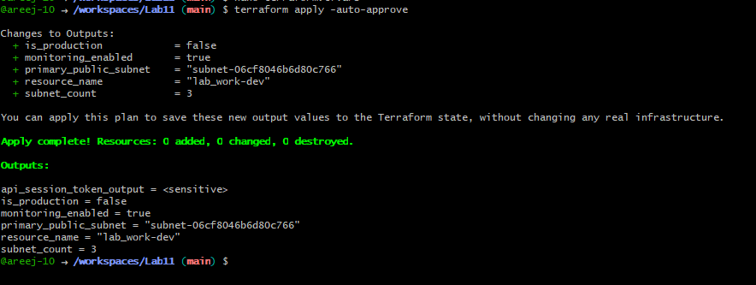
Task 4 — Maps and Objects
task4_tags_variable_added.png
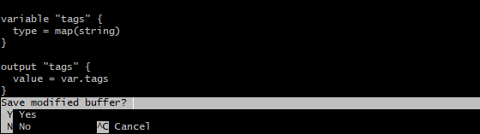
task4_tags_output.png
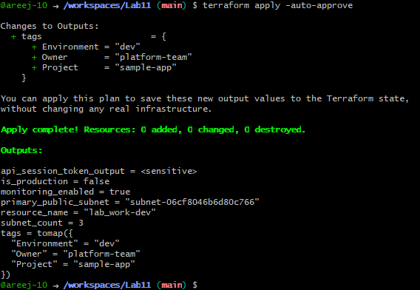
task4_server_config_output.png
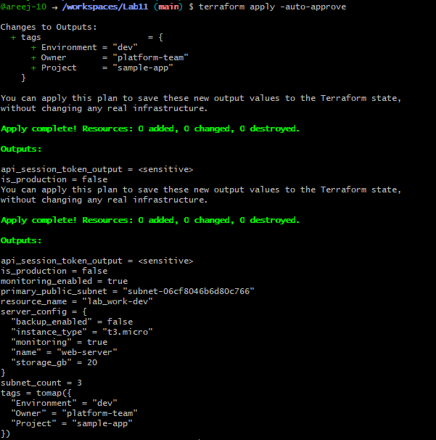

Task 5 — Collections: list, tuple, set & mutation via locals
task5_collections_defined.png
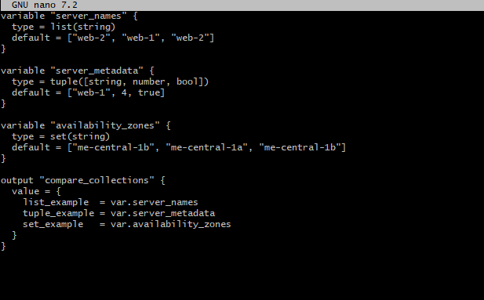
task5_compare_collections.png
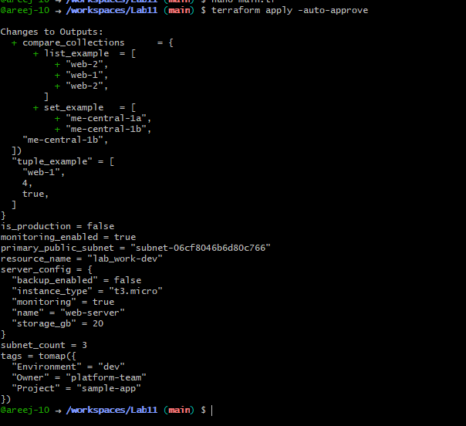
task5_locals_mutations.png
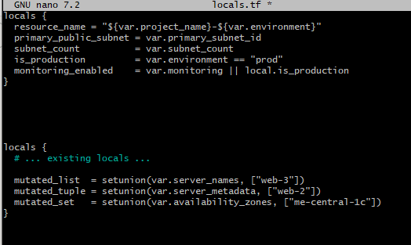
task5_mutation_comparison.png
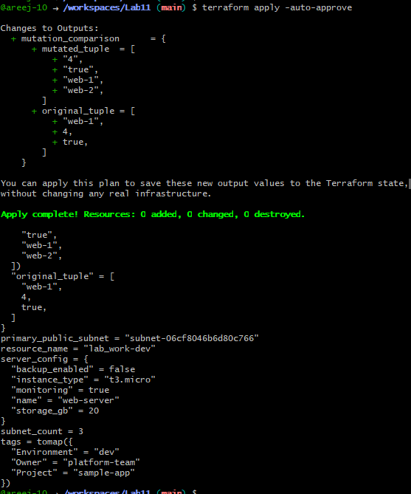

Task 6 — Null, any type & dynamic values
task6_optional_tag_variable.png
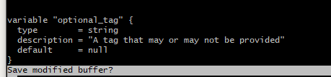
task6_locals_merge.png
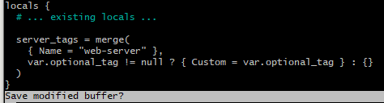
task6_optional_tag_no_value.png
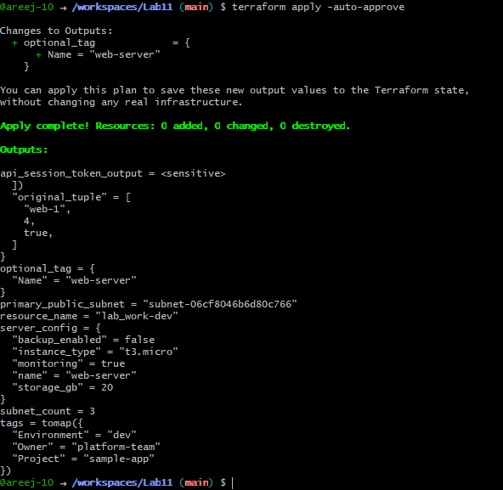
task6_optional_tag_with_value.png
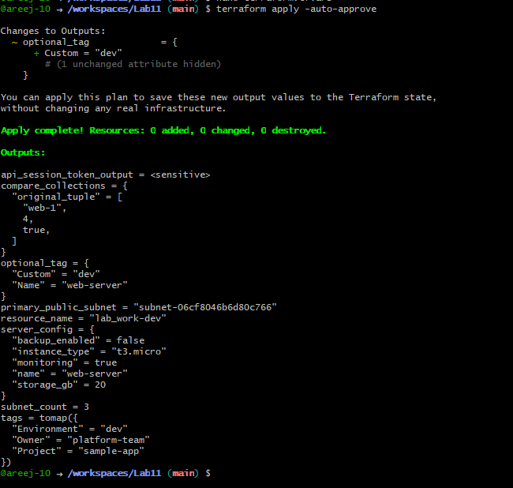
task6_dynamic_value_string.png
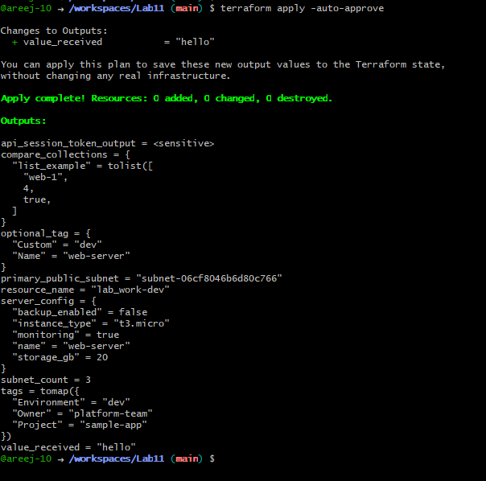
task6_dynamic_value_number.png
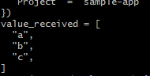
task6_dynamic_value_list.png
task6_dynamic_value_map.png
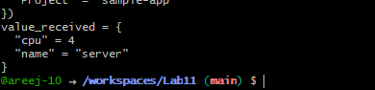
task6_dynamic_value_null.png
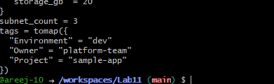
Task 7 — Git ignore
task7_gitignore_created.png
Task 8 — Clean-up then build real infra (VPC, Subnet, IGW, routing, default route table)
task8_clean_files.png
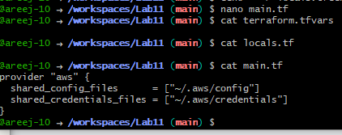
task8_variables_recreated.png
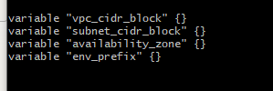
task8_vpc_resources_added.png
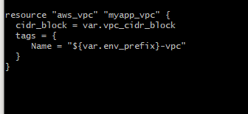
task8_subnet_resources_added.png
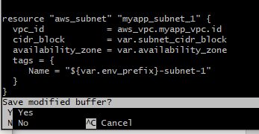
task8_terraform_tfvars_vpc_values.png
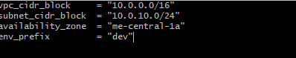
task8_vpc_subnet_apply.png
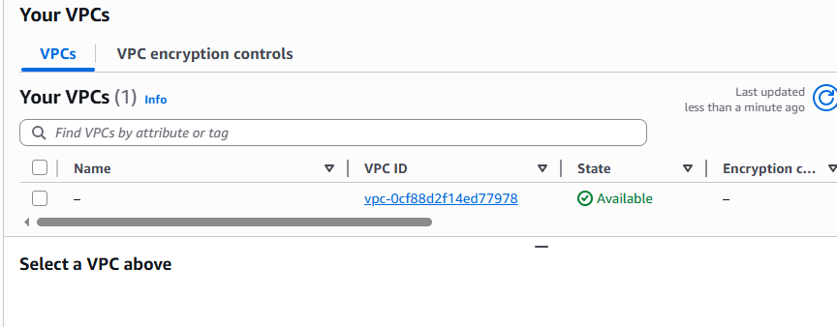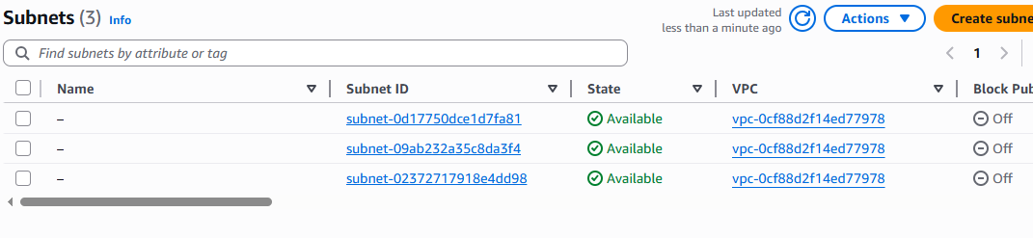
task8_igw_route_table_before_apply.png
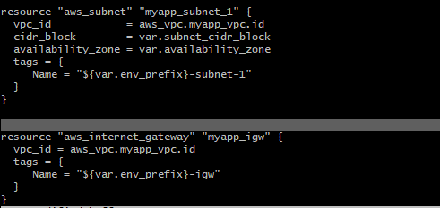
task8_igw_route_table_after_apply.png
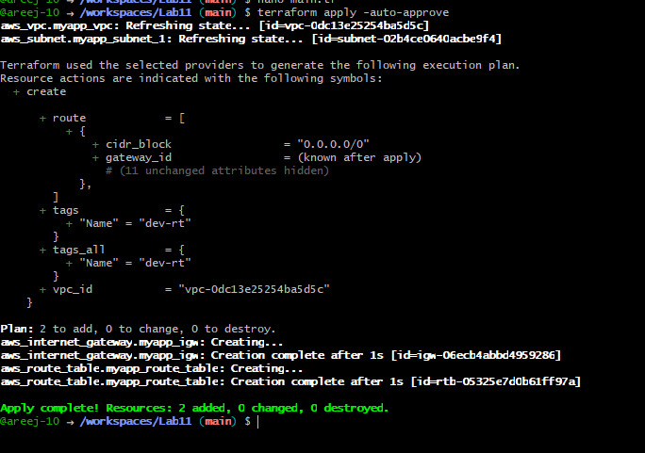
task8_association_apply.png
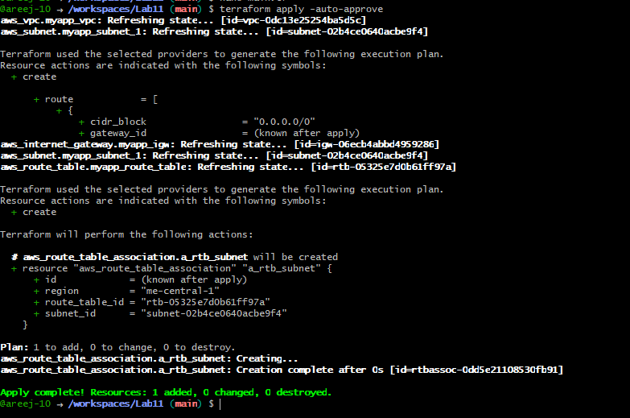
task8_default_route_table.png
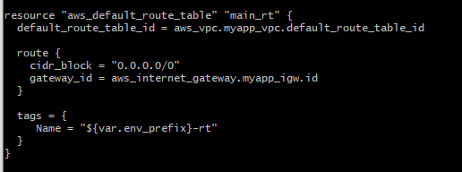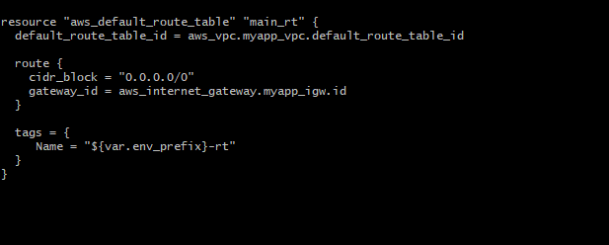
task8_default_route_table_apply.pn
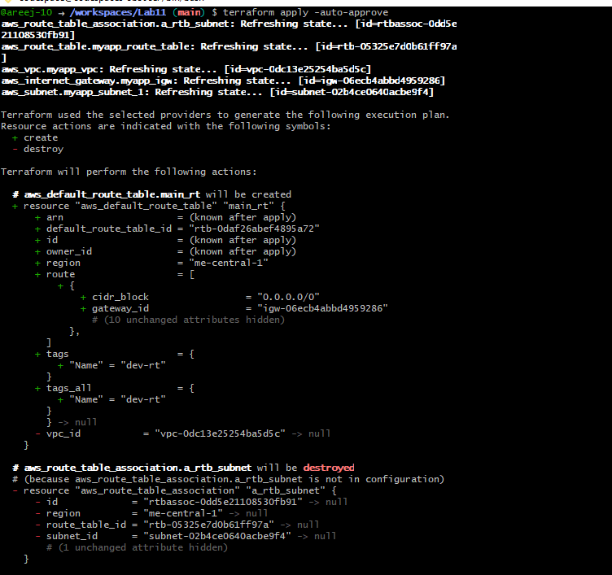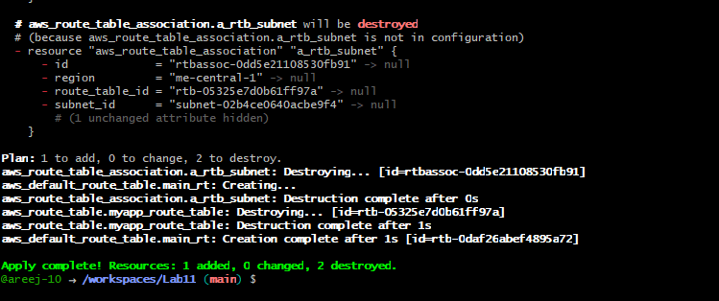
Task 9 — Security Group, key pair, EC2 instance, user_data & nginx
task9_my_ip_variable_added.png
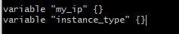
task9_public_ip_curl.png
task9_security_group_apply.png

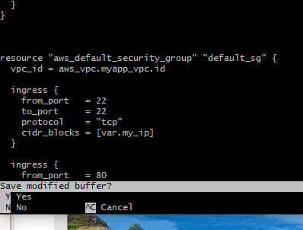
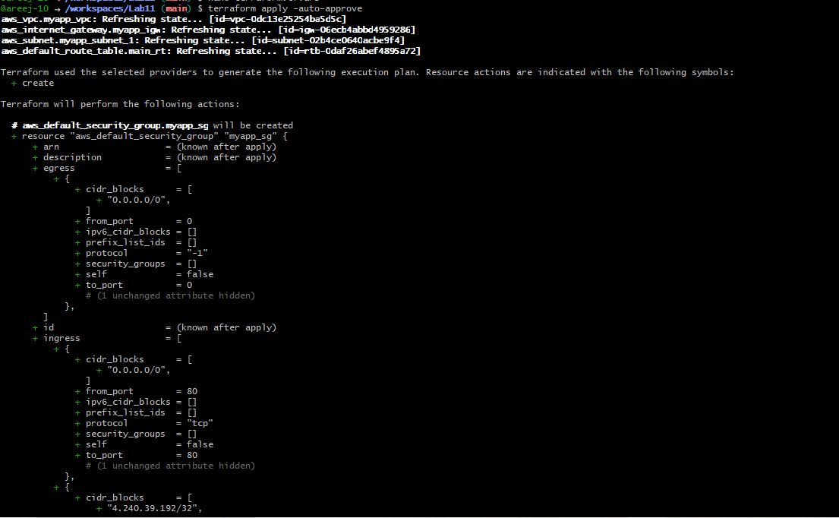
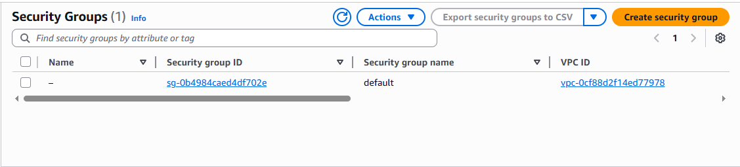
task9_public_ip_curl.png
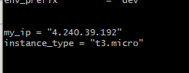/32
task9_keypair_created_and_saved.png
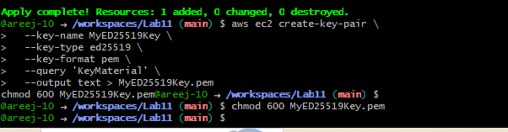

task9_instance_type_set.png
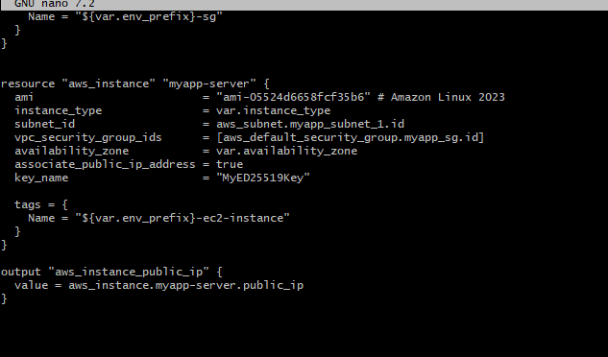
task9_ec2_apply_and_public_ip.png
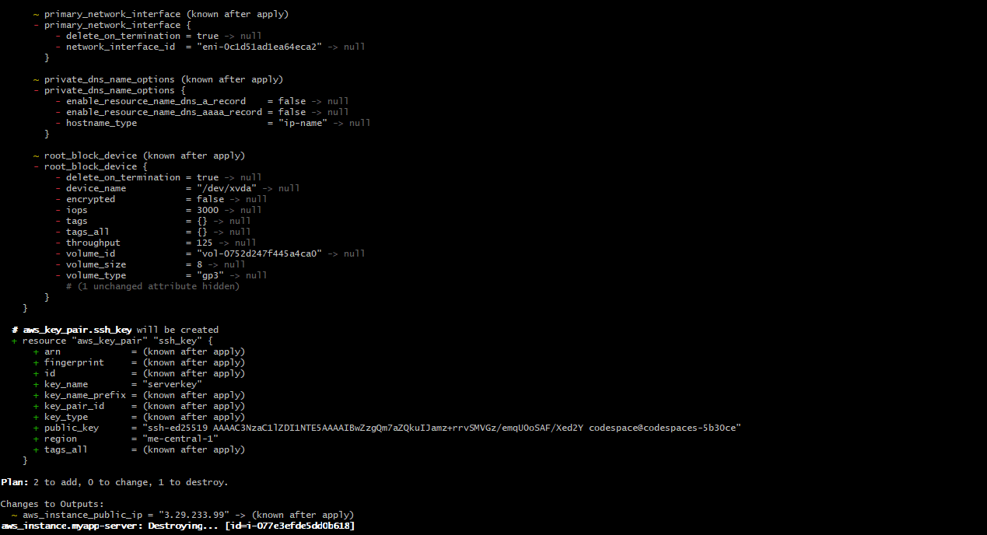
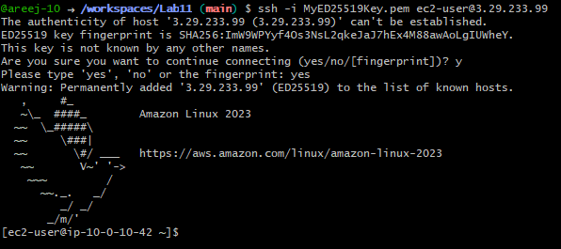
task9_ssh_into_ec2.png
task9_ssh_keypair_and_ssh.png
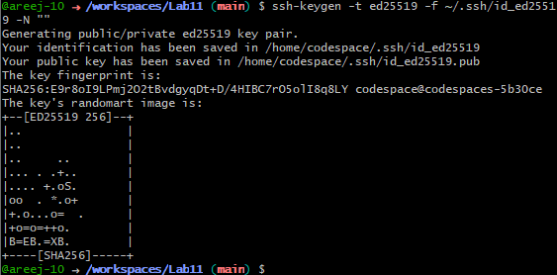
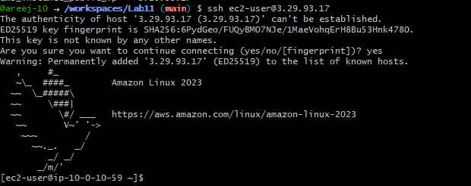
task9_nginx_local_curl.png
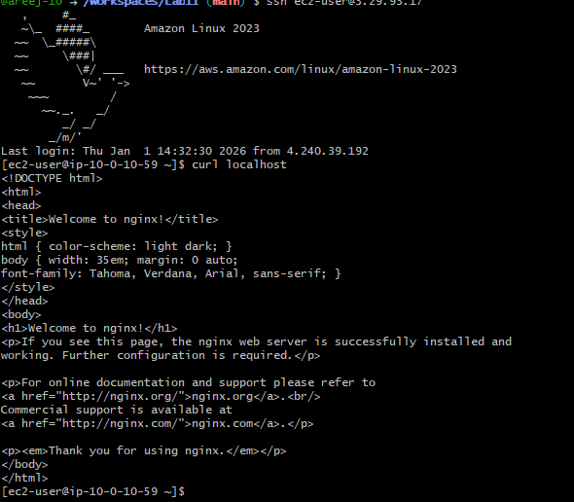
task9_nginx_browser_page.png
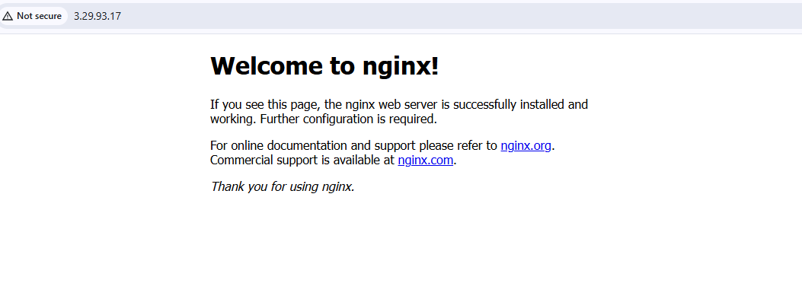
Cleanup — Destroy resources & verify state
cleanup_destroy.png
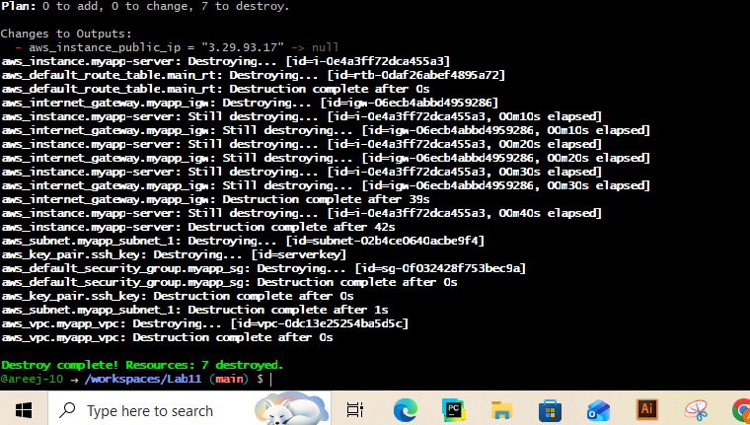
cleanup_state_files.png
cleanup_verify_no_secrets.png
